**Tutorial No. 2**

**Aim** :- Implement a client-server calculator program using multithreading.

**Theory** :-

Multithreading

Multithreading in java is a process of executing multiple threads simultaneously. Thread is basically a lightweight sub-process, a smallest unit of processing. Multiprocessing and multithreading, both are used to achieve multitasking.But we use multithreading than multiprocessing because threads share a common memory area. They don't allocate separate memory area so saves memory, and context-switching between the threads takes less time than process.Java Multithreading is mostly used in games, animation etc.

Advantages of Java Multithreading

* It doesn't block the user because threads are independent and you can perform multiple operations at same time.
* You can perform many operations together so it saves time.
* Threads are independent so it doesn't affect other threads if exception occur in a single thread.

We use multithreading in client-server architecture because we don’t want only a single client to connect to server at a particular time but many clients simultaneously. We want our architecture to **support multiple clients at the same time**. For this reason, we must use threads on server side so that whenever a client request comes, a separate thread can be assigned for handling each request.

With our basic server-client program, the request which comes even a nano-second first would be able to connect to the server and the other request would be rejected as no mechanism is provided for handling multiple requests simultaneously. To overcome this problem, we use threading in network programming.

**Class Diagram :-**

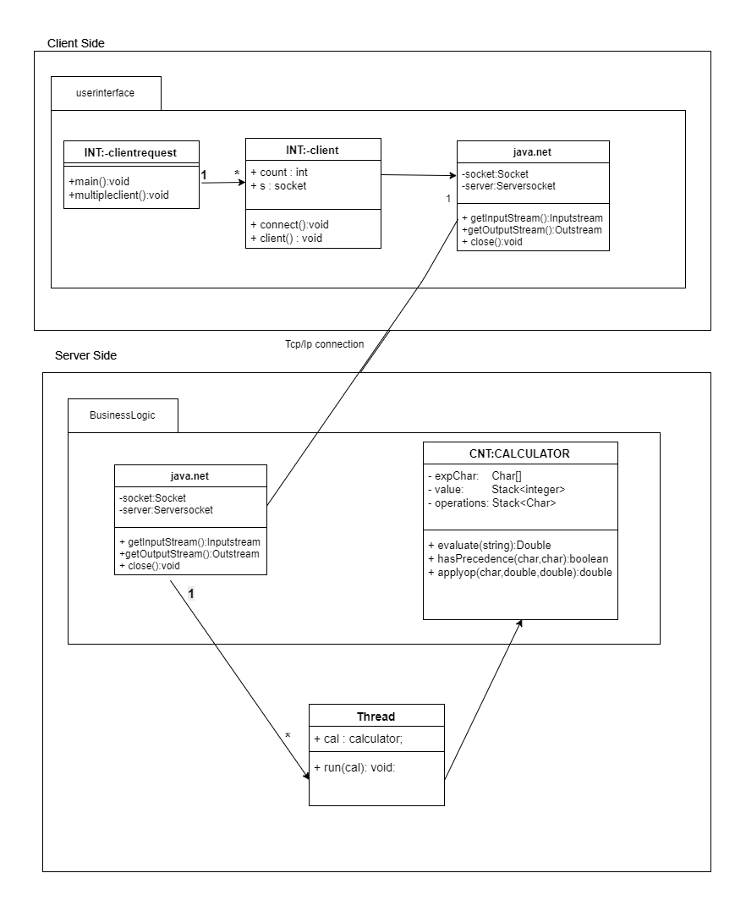

**Conclusion**:- Thus we have studied the use of multithreading in client server architecture using our calculator program. For each client a server side thread will be created which implements the program and returns the user to the client.